Computer Science

A2 Coursework

Callum Reid

**Prototype:**

In this section I will be creating a prototype for the Bayburn Fitness management system. This prototype will only include a limited amount of the functionality that will be in the completed system, however it will display enough functionality to demonstrate how the system should work upon completion. A prototype is useful as it allows a developer to discuss with their client about their progress and what they wish to do going forward. A prototype allows for areas of improvement to be identified and for plans to be made on how to best approach completing the final system.

Before starting my prototype, I must identify some important features that I wish to include. In the diagrams below I will display these features for each stakeholder.

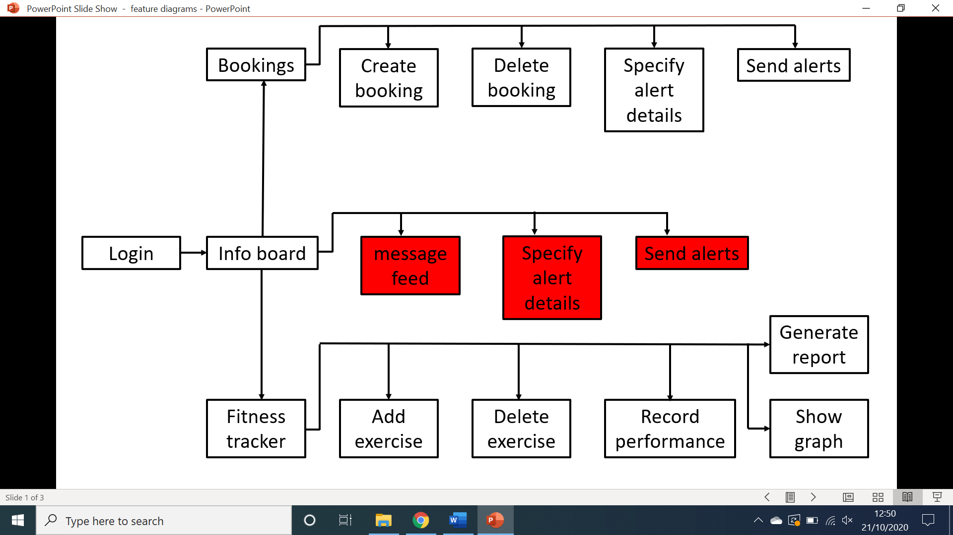**Client:**

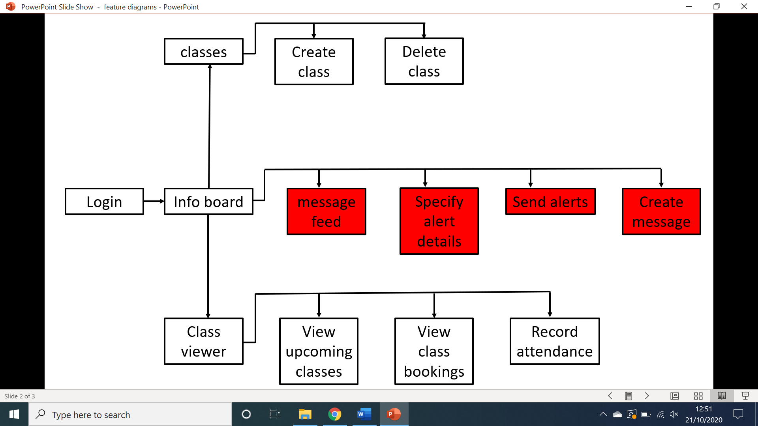 **Trainer:**

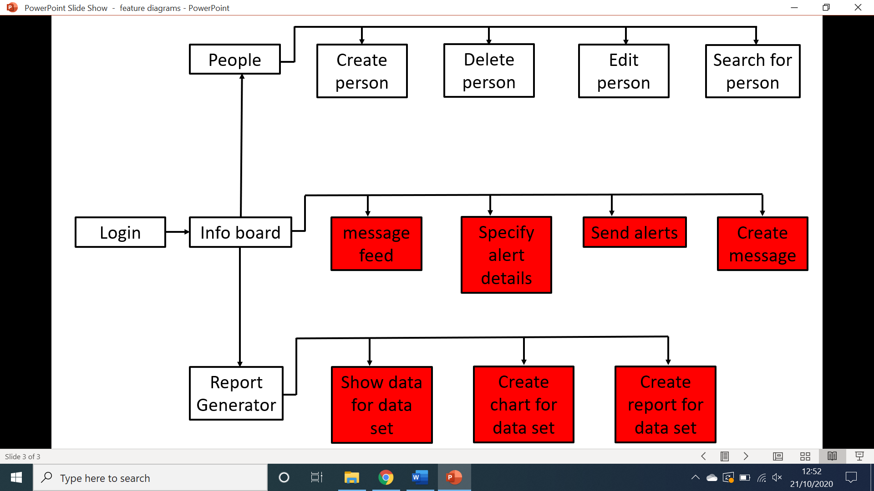**Manager:**

**Justification of prototype features**

Below I will justify why I have picked the features I have to be implemented into the prototype.

* **Login (Client, Trainer, Manager):** the login page is essential for the system to function as it allows users to access the system using their login credentials whilst also ensuring that each user is redirected to their appropriate screens.
* **Bookings (Client):** the bookings page is essential as it allows the client to access the functionality of the system that will allow them to book classes.
* **Create booking (Client):** this feature will allow a user to browse the available classes using a calendar system and book themselves into any of these available classes. This is essential as the focus of the system is around booking classes
* **Delete booking (Client):** this feature will allow a user to delete any of their bookings if they are unable to attend, bookings will also be deleted if the class has been completed. This was added into the prototype as an essential piece of functionality to ensure the client would be able to control their bookings more effectively.
* **Specify alert details (Client):** this feature will allow clients to select when they will receive notifications about upcoming classes as well as select how they wish to receive these notifications. This was added into the prototype as it is essential in order to send accurate notifications to clients.
* **Send alerts (Client):** this feature will allow clients to be sent messages via email or SMS automatically in order to inform them of their class. This feature was added to the prototype to demonstrate the system’s ability to send both SMS messages and emails at a certain time.
* **Information board (Client, Trainer, Manager):** this screen is essential as it gives the user access to the functionality of the information board messaging system and so it was added to the prototype.
* **Fitness tracker (client):** this screen is essential as it gives the user access to the functionality of the fitness tracking system and so it was added to the prototype.
* **Add exercise (Client):** this feature allows the client to add an exercise that they wish to track to the system, I have added it to the prototype as it is an integral part of the fitness tracking system.
* **Delete exercise (Client):** this feature allows the client to delete one of their selected exercises from the system, I have added this to the protype as it is essential for ensuring the client has full control over the fitness tracker.
* **Record performance (client):** this feature allows a client to record the weight, reps, sets and time for which they completed an exercise, this is an integral part of the fitness tracking system and so it was added to the prototype.
* **Show graph (client):** this feature was added to the prototype as it demonstrates the ability of the system to generate an appropriate graph for a specific data set.
* **Generate report (client):** this feature allows all the data for a specific exercise to be presented in a word document as well as having the graph be generated and placed in the word document as well, this feature was added to the prototype as it demonstrates the system’s ability to generate reports and documents.
* **Classes (Trainer):** this screen gives the trainer access to the functionality required to add, edit, delete and view classes, therefore making it an essential part of the system and thus it was added to the prototype.
* **Create class (Trainer):** this feature allows a trainer to create a class for clients to book into, this was added to the prototype as without it, class bookings would become impossible.
* **Delete class (Trainer):** this feature allows the trainer to delete a class that has been created, this is essential as it gives the trainer complete control over their classes.
* **Class viewer (Trainer):** this screen allows a trainer to view all of their upcoming classes, this has been added to the prototype as it is necessary for the booking process of the system.
* **View class bookings (Trainer):** this feature will allow a trainer to select an upcoming class and see who has been booked into it, this feature is essential as it is required for the attendance system.
* **Record attendance (Trainer):** this feature will allow a trainer to mark a person as present to a class, this feature was added to the prototype to complete the class/booking system.
* **People (Manager):** this screen is essential as it gives the manager access to the functionality that will allow them to create, delete, update or retrieve information about system users.
* **Create person (Manager):** this feature allows a manager to create an account for someone to use the system, this feature is essential as without it there would be no way of accessing the different views of different stakeholders.
* **Delete person (Manager):** this feature allows a manager to delete a person’s account, this feature is essential as it gives the manager full control of the accounts on the system.
* **Edit person (Manager):** this feature is essentialas it allows a manager to edit the information of a previously created account, thus giving them complete control over the accounts on the system.
* **Search for person (Manager):** this feature allows a manager to search for a person to edit, delete or simply view their data, this feature is essential as it demonstrates the ability of the system to retrieve data efficiently.
* **Report generator (Manager):** this screen is essential as it will give the manager access to the functionality needed to generate detailed reports and charts on any given data set.

**Non-implemented features:**

Below are the features that I have decided not to implement in the prototype, I will also justify why I have not implemented them.

* **Message feed (Client, Trainer, Manager):** this feature was not implemented in the prototype as it was not a priority and because all the necessary functionality to make a message feed had already been displayed in other aspects of the system.
* **Specify alert details (Client, Trainer, Manager):** this feature was not added as it has already been demonstrated in another aspect of the system and therefore was not priority.
* **Send alerts (Client, Trainer, Manager):** this feature was not added as it has already been demonstrated in another aspect of the system and therefore was not priority.
* **Create message (Trainer, Manager):** this feature was not implemented in the prototype as it was not a priority and because all the necessary functionality to make a message feed had already been displayed in other aspects of the system.
* **Show data for data set (Manager):** this feature was not implemented in the prototype as it was not a priority and because all the necessary functionality to make a message feed had already been displayed in other aspects of the system.
* **Create chart for data set (Manager):** this feature was not added as it has already been demonstrated in another aspect of the system and therefore was not priority.
* **Create report for data set (Manager):** this feature was not added as it has already been demonstrated in another aspect of the system and therefore was not priority.
* **Encryption (General):** this feature was not implemented in the prototype as it is not necessary for the system to function and thus was not priority.

**Screens and outputs of prototype**

In this section I will be showing all of the various screens designed for the prototype and I will also be showing a screenshot for every output of the prototype.

* Messages error/info
* Graphs
* Emails
* Texts
* Word document
* treeviews

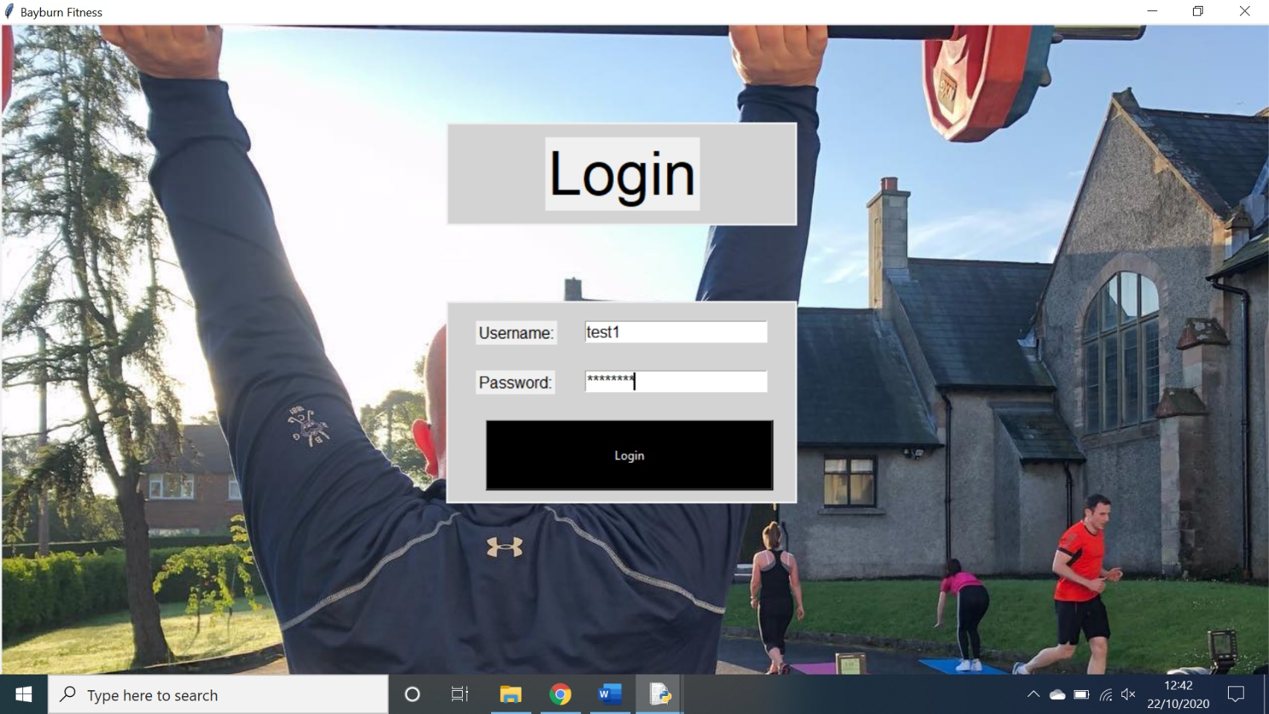**Login:**

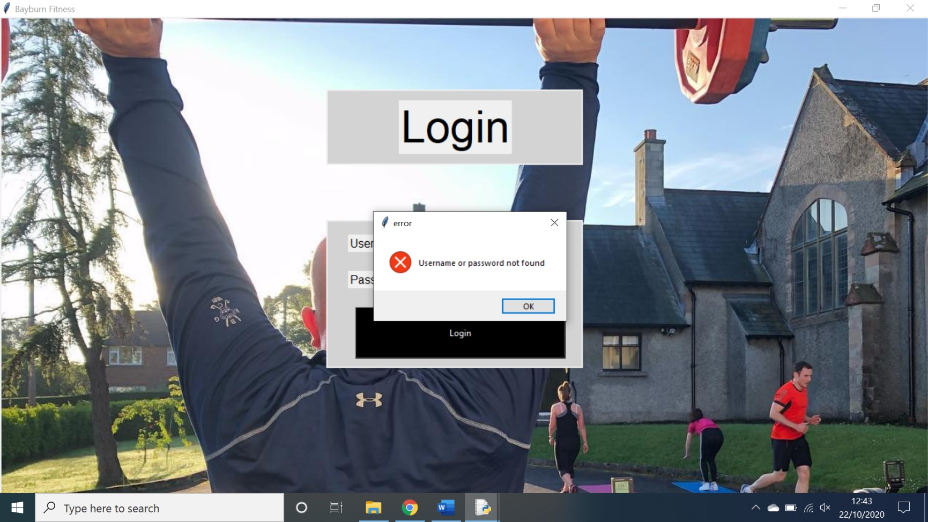This is the login screen in its base state, its only output is error messages if it cannot find the login credentials or the user has not entered data.

There are multiple error messages throughout the system however this is an example of one.

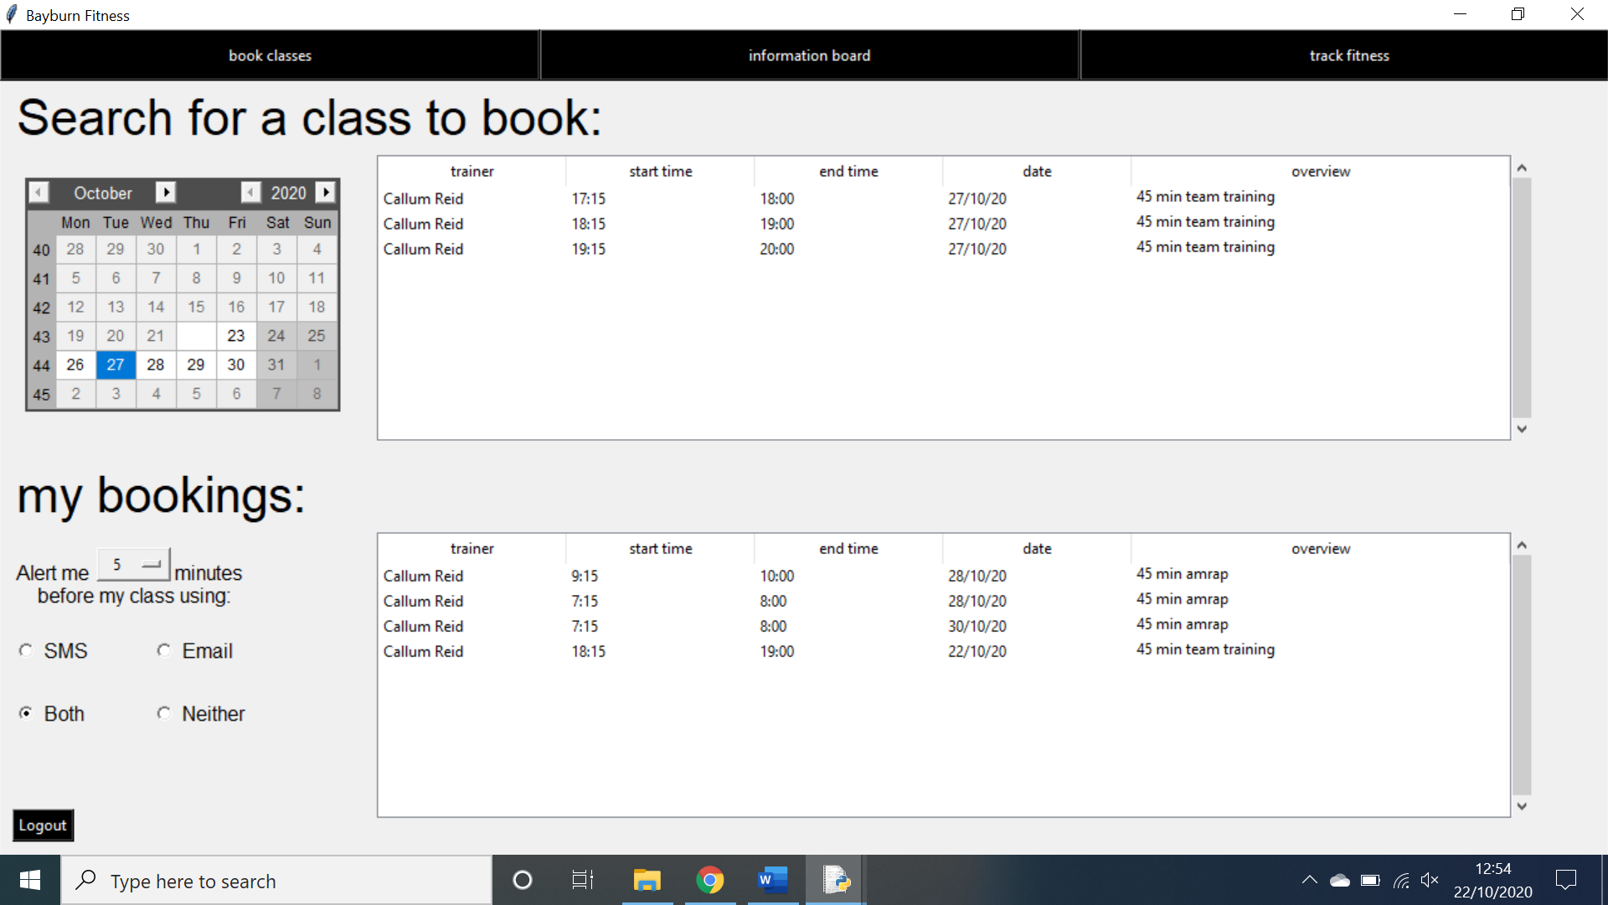**Client bookings page:**

This is the screen in the base state. It outputs treeviews and texts and emails. The treeviews display the possible classes that a client can book as well as the bookings that they have made. There are multiple treeviews however these are examples of two.

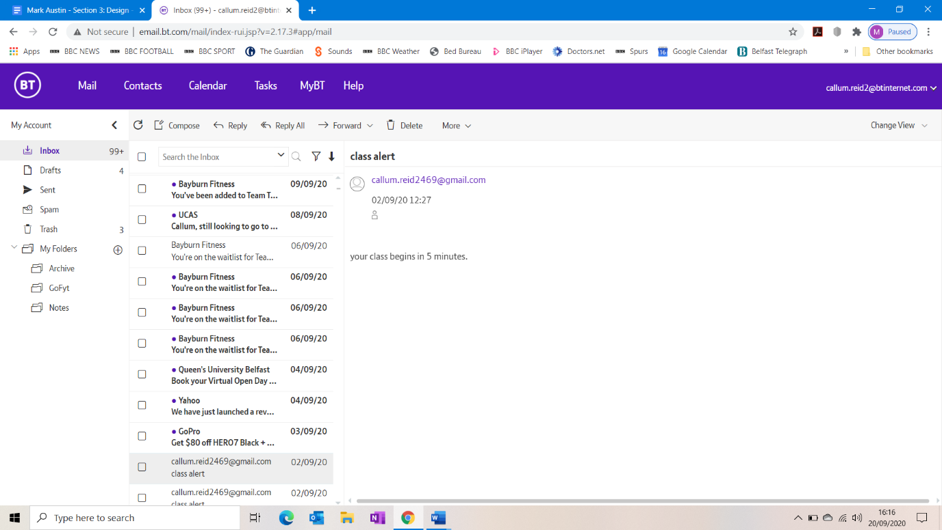

This is an example of an email that is sent to a client the specified amount of time before a class. There are other emails throughout the system however this is an example of one.

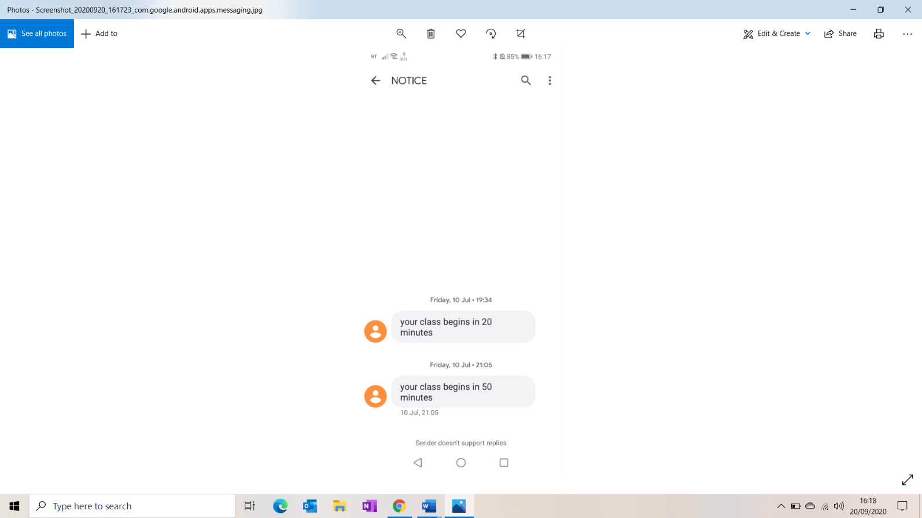

This is a text message that is sent the specified number of minutes before a client’s class begins. There are several emails sent throughout the system however this is an example of one.

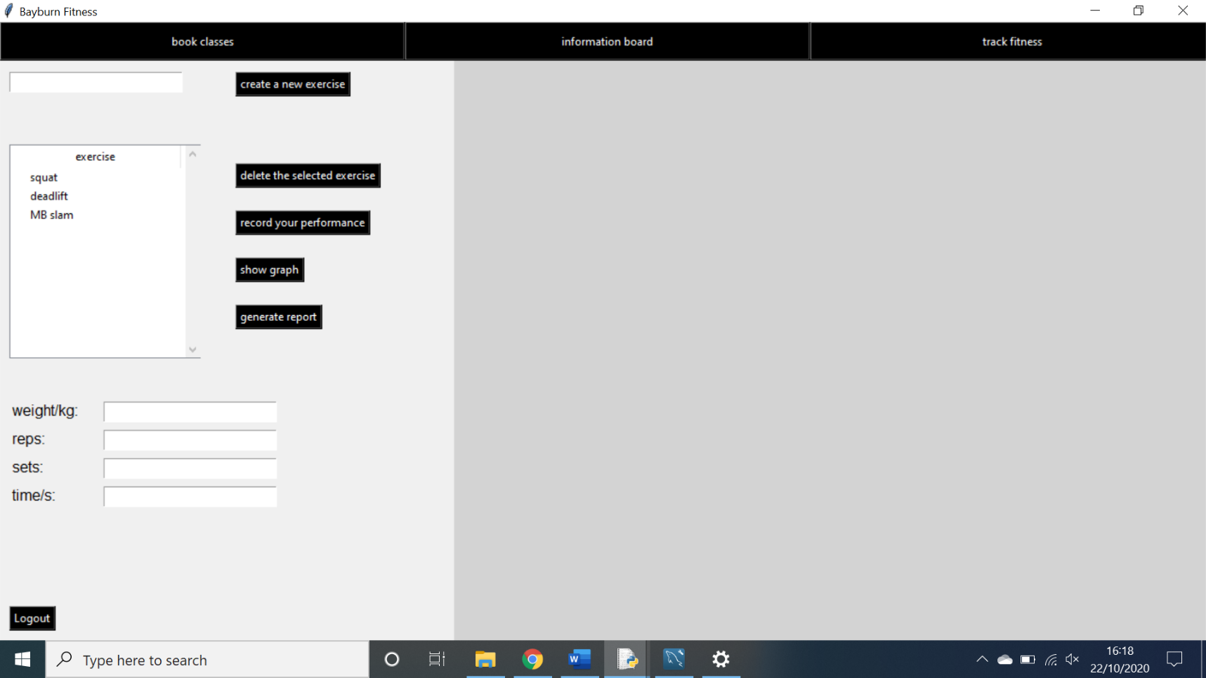**Client fitness tracking page:**

This is the page in its base state. The page outputs one interactive treeview, confirmation messages, error messages, word documents and a graph.

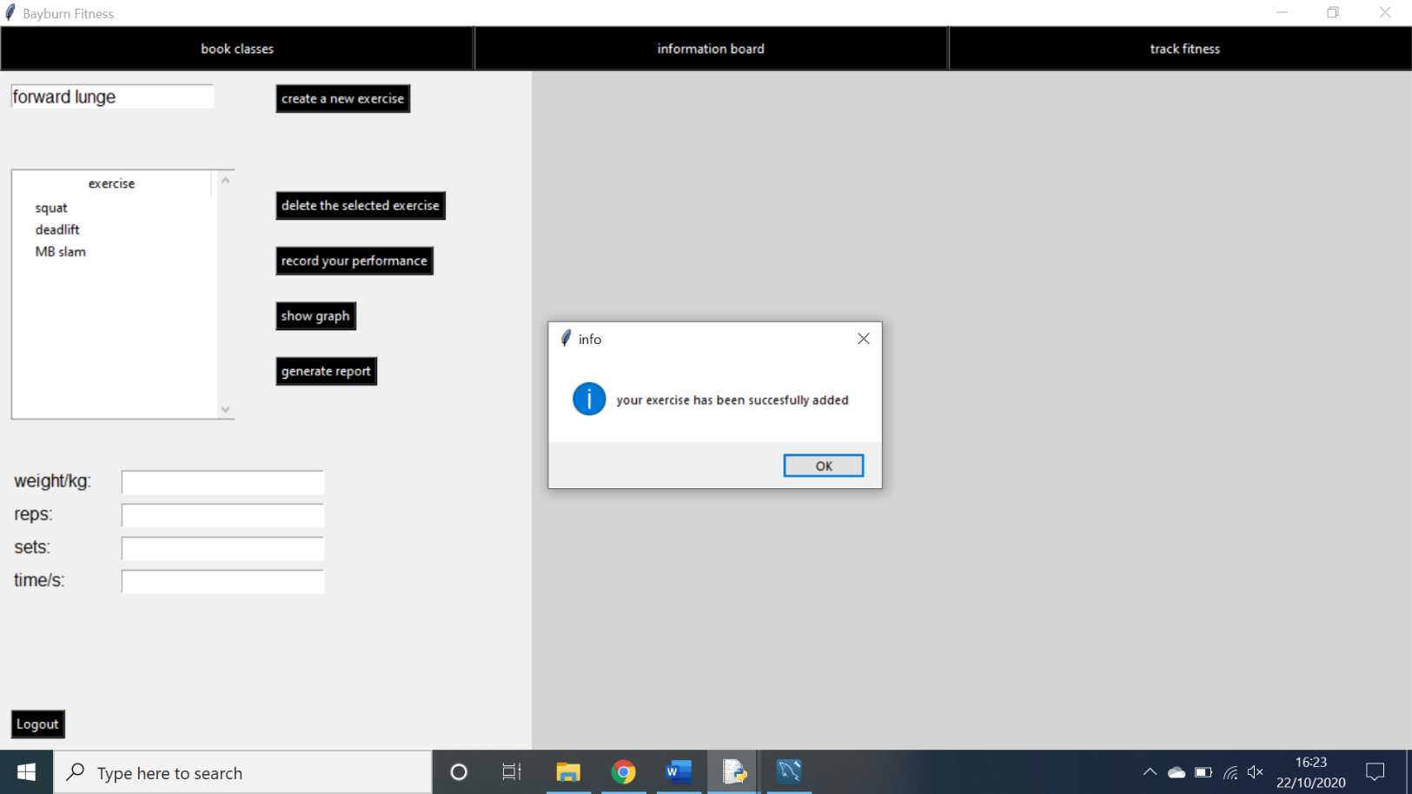

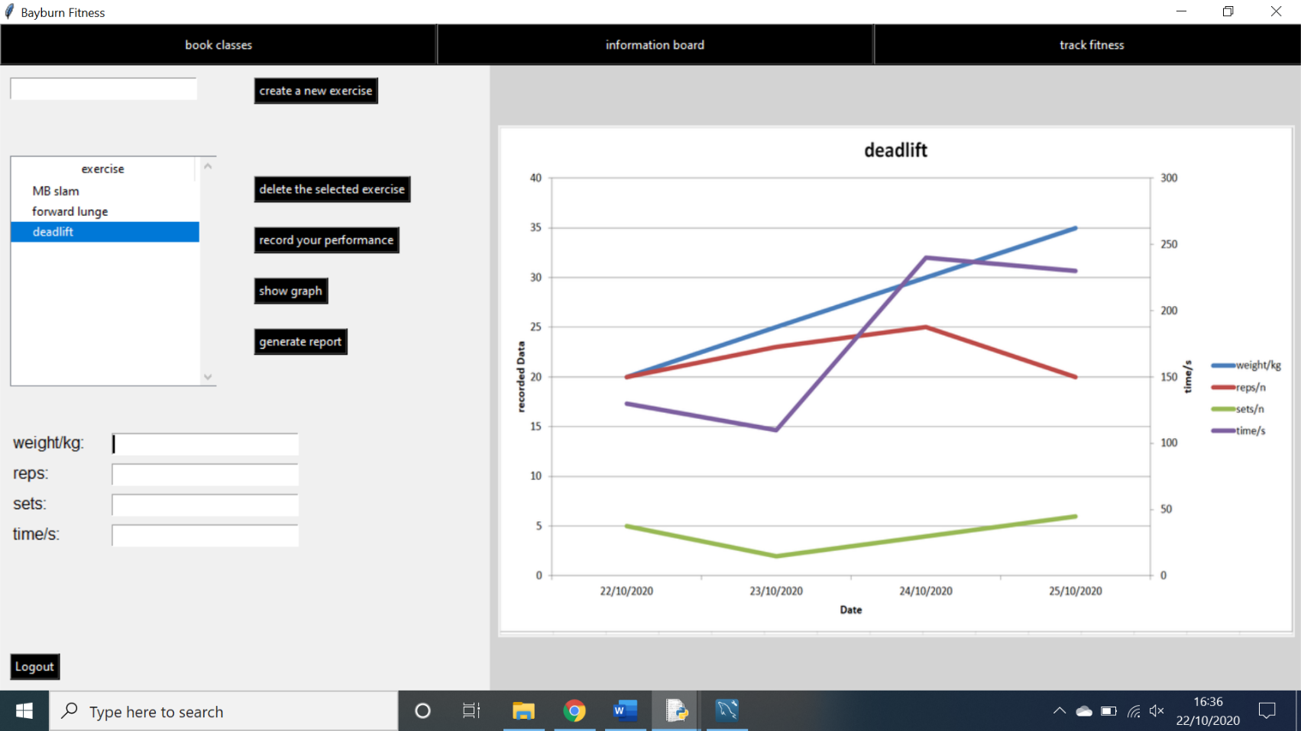This is an example of a confirmation message when you add an exercise to the tracker. There are several confirmation messages in the system, and this is only an example of one.

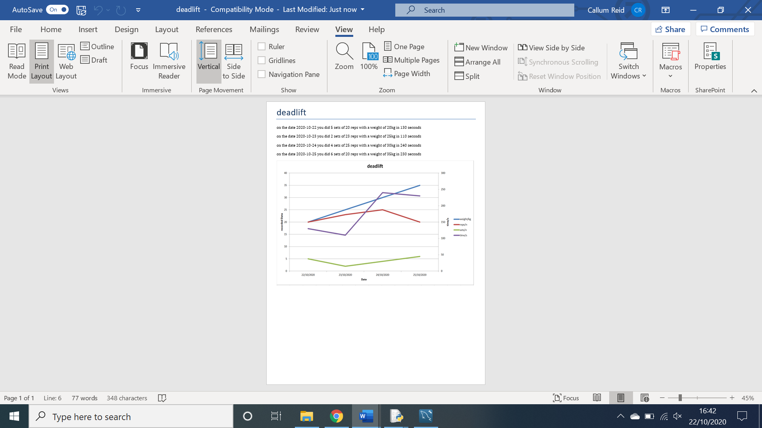This the graph that the fitness tracker outputs. There are several graphs created by the system however this is an example of one.

This is a word document that is generated by the system for the fitness tracker. There are several examples of word documents in the system however this is only one of them.

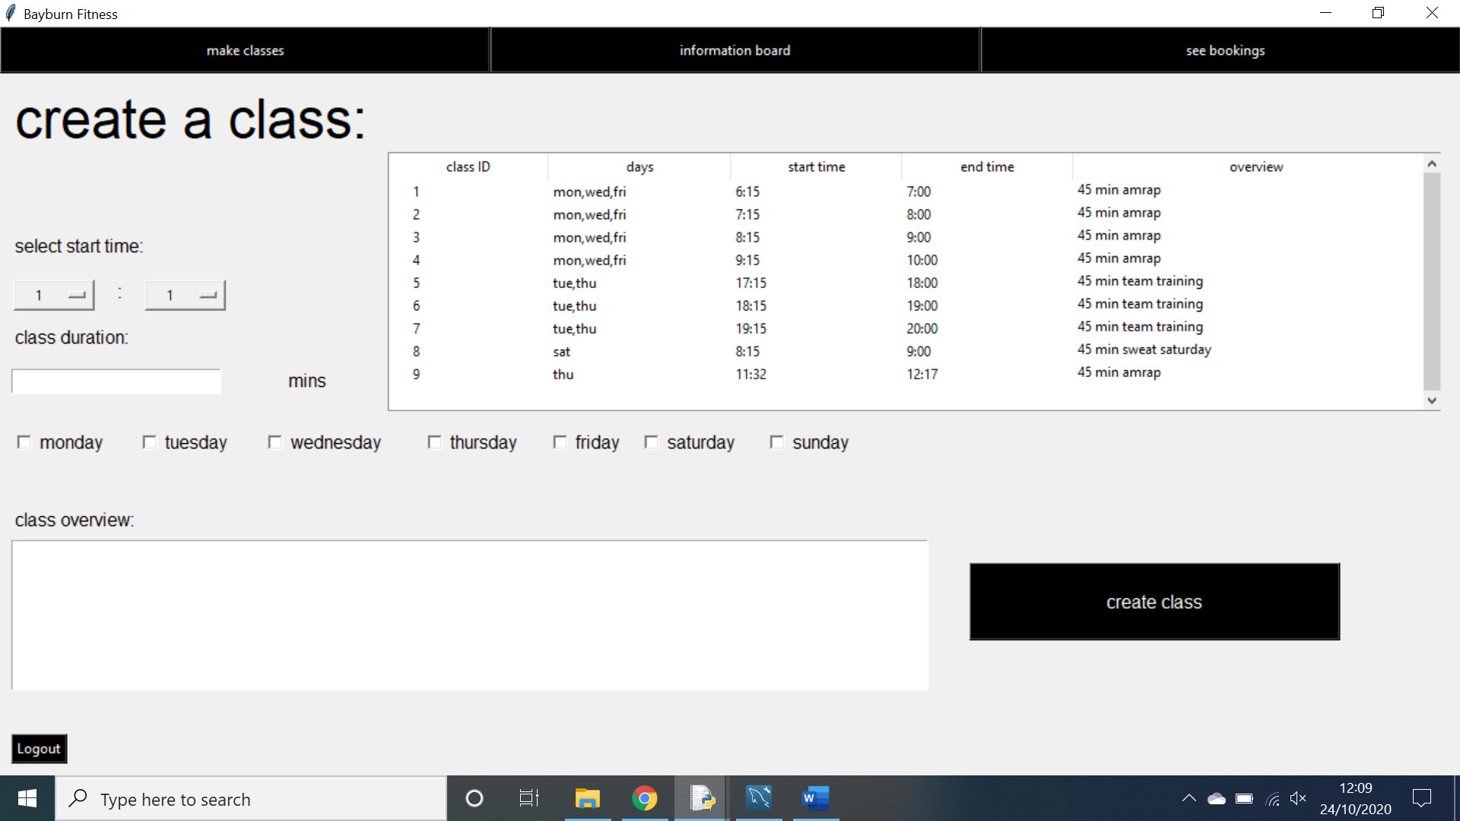**Create a class page:**

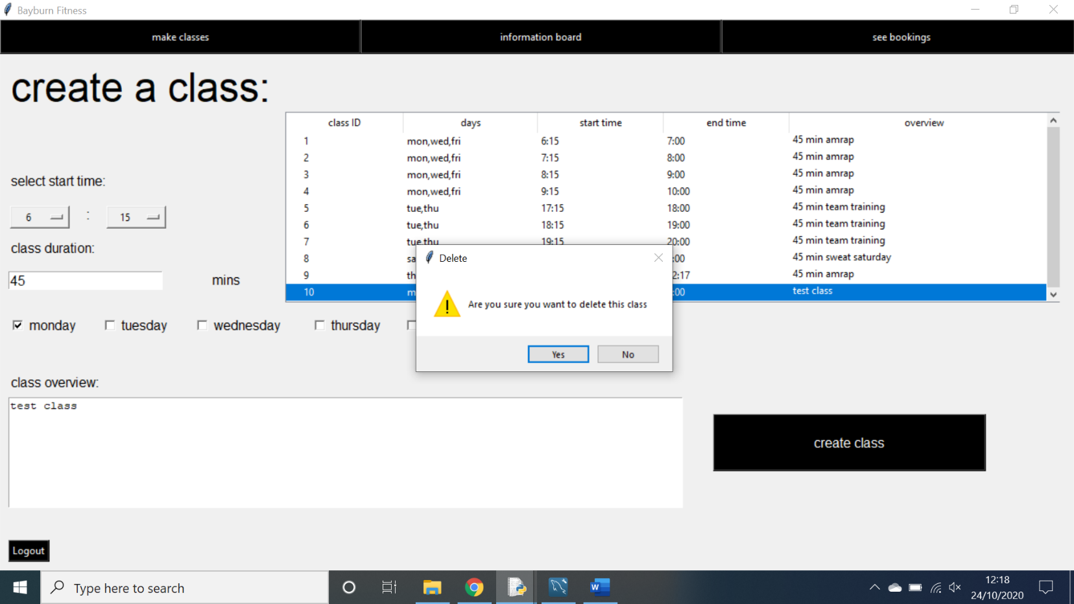This page outputs error messages, confirmation messages and interactive treeviews and question boxes.

This is an example of a question box that is outputted when you try to delete a class.

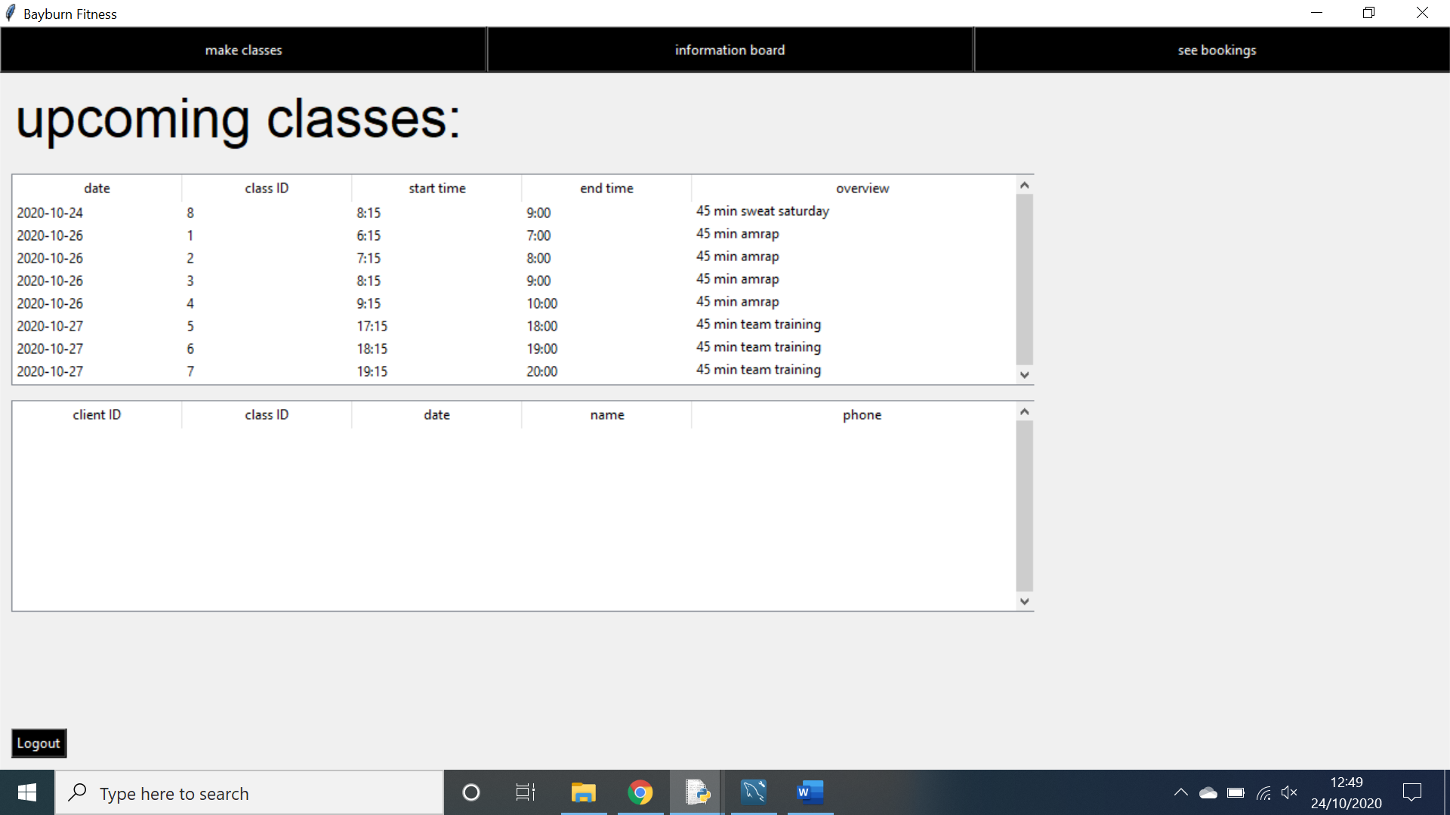**Trainer check bookings page:**

This page outputs interactive treeviews, conformation messages, error messages and question boxes. All of these outputs have had examples of them shown previously.

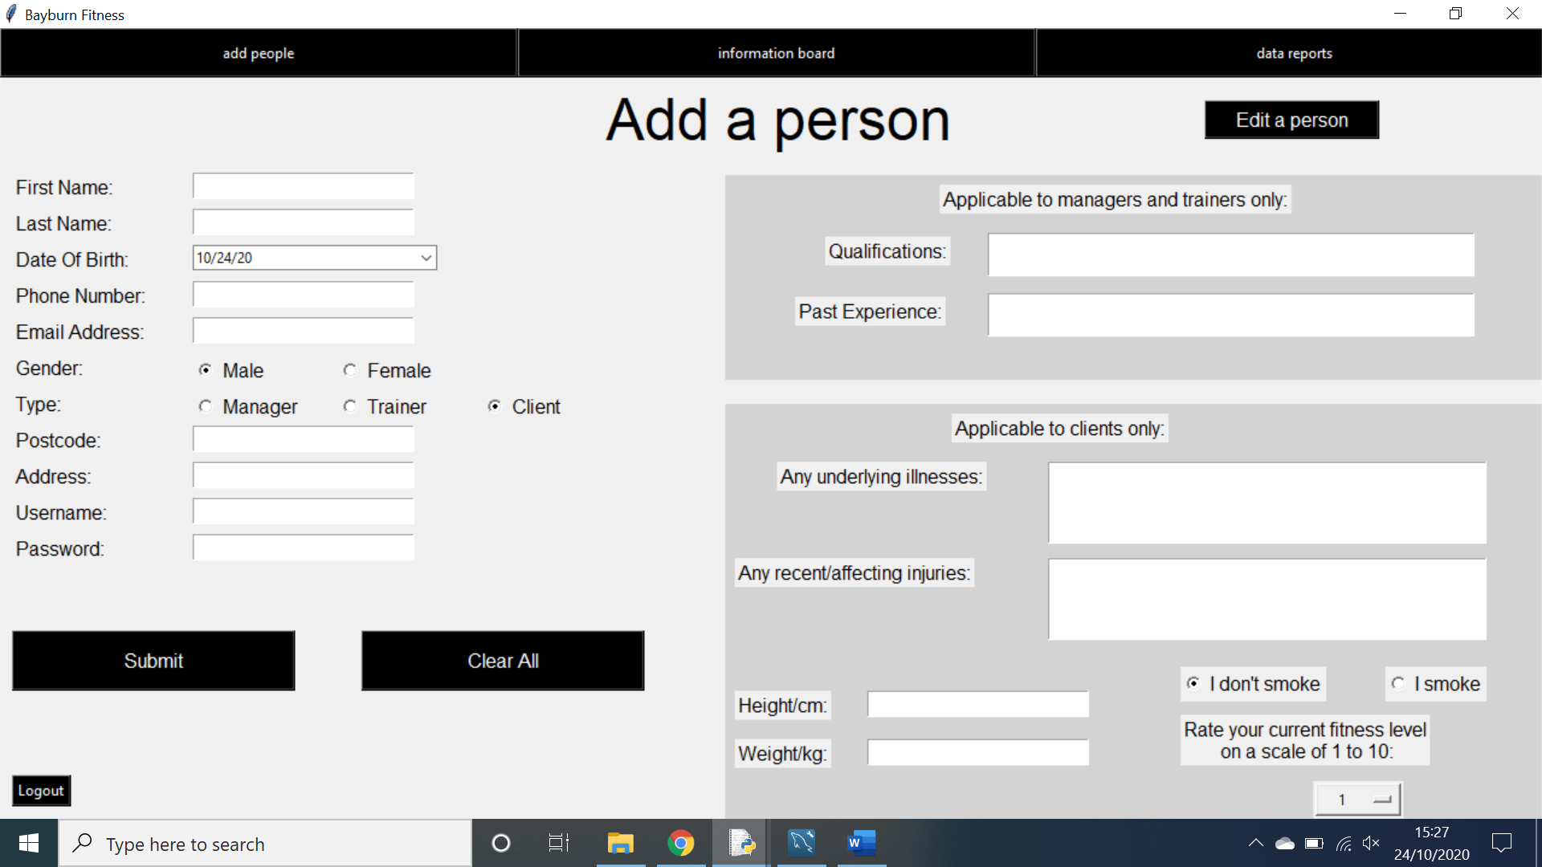**Add a person page:**

This page outputs error messages and confirmation messages. Both of these outputs have been shown in previous examples.

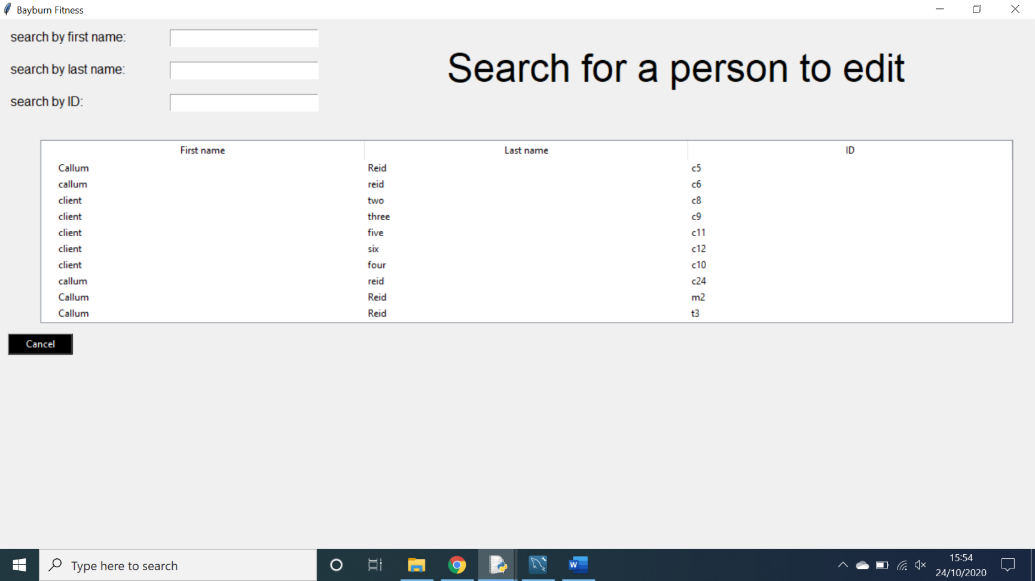**Search for person page:**

This screen only outputs interactive treeviews, treeviews have already been demonstrated in previous examples on other screens.

**Broad aims and goals for the prototype:**

* All stakeholders should be able to log into their respective accounts and be redirected to the appropriate screens.
* Managers should be able to create an account for trainers, clients and other managers, as well as being able to delete accounts, search for accounts and edit the information attached to accounts.
* Clients should be able to book into classes and delete bookings at will and with ease whilst also being able to define when and how they are notified on these classes.
* Clients should be able to track their fitness on the system and generate charts and save reports of their tracked fitness.
* Trainers should be able to create and delete classes at will and with ease.
* Trainers should be able to view all upcoming classes and also view the people attending these classes, they will also need to be able to mark these people present to the classes.
* All fields of entry should be validated and verified before being added to the database.
* Appropriate error messaging should be displayed when data is inputted incorrectly or a user attempts to do something in an incorrect manor.
* Appropriate information messages should be displayed to show when the system has performed an action.
* The system should overall be intuitive and easy to use.

**Prototype development:**

**Login page:**

This is the login screen that the user is greeted with upon running the programme. It uses a background picture however the terminal in the centre where the username and password is entered uses the black white and grey colour scheme which I have maintained throughout the system. Here the user can login to their respective accounts using their given username and password. Upon logging in the system will automatically redirect them to the appropriate screen depending on if they are a manager, trainer or client.



As shown above, if the user enters an incorrect username or password the system will output an error message. However, if the user enters the correct username and password they will be redirected to the appropriate page.

**Client bookings page:**

This is the page the user is greeted with if they login as a client. From here they can select any date available on the calendar to search for classes, the calendar only allows the user to select dates in the future to ensure the client cannot book themselves into past classes. When a date is selected the top treeview populates itself with all the classes that can be booked for that date. Upon clicking on one of the classes in the treeview, it is booked. All of the users upcoming bookings are placed in the bottom treeview and by clicking on them the booking can be deleted and removed from the treeview. A user cannot book themselves into the same exact class more than once. In the bottom left of the screen there as an area to select your alert preferences. This allows a client to select how many minutes before a class they would like to be alerted about it as well as how they wish to be alerted about it. They can be alerted via email, SMS messages, both or neither.



This is the email that is sent to a client automatically if they wished to be notified of a class via email 5 minutes before the class.



These are the text messages sent to a client automatically if they chose to be alerted 20 or 50 minutes before a class via SMS.

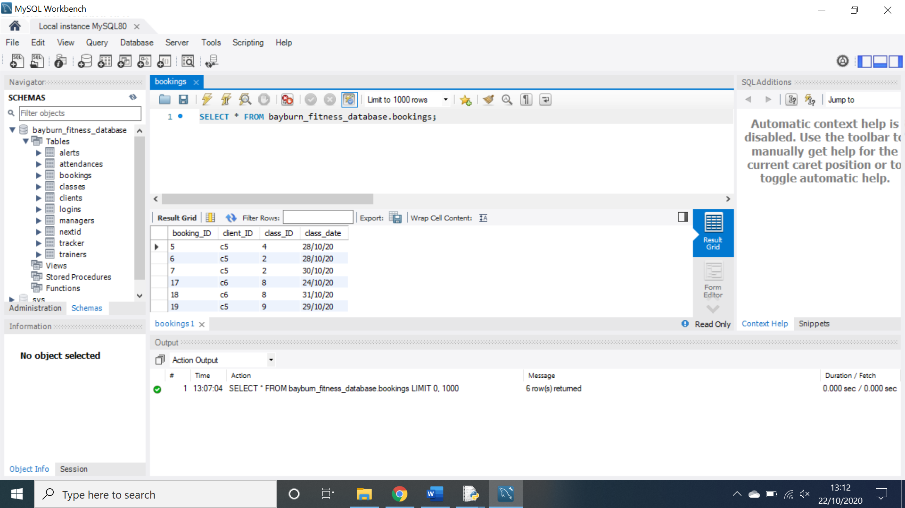

When a client selects a class to book themselves into, the booking is added to the database in the above format. The system is also sure to remove any duplicate bookings. The bottom treeview then updates to show all of the bookings for the currently logged in client. When a booking is selected to be deleted from the bottom treeview it is deleted from the database and the bottom treeview updates once again.

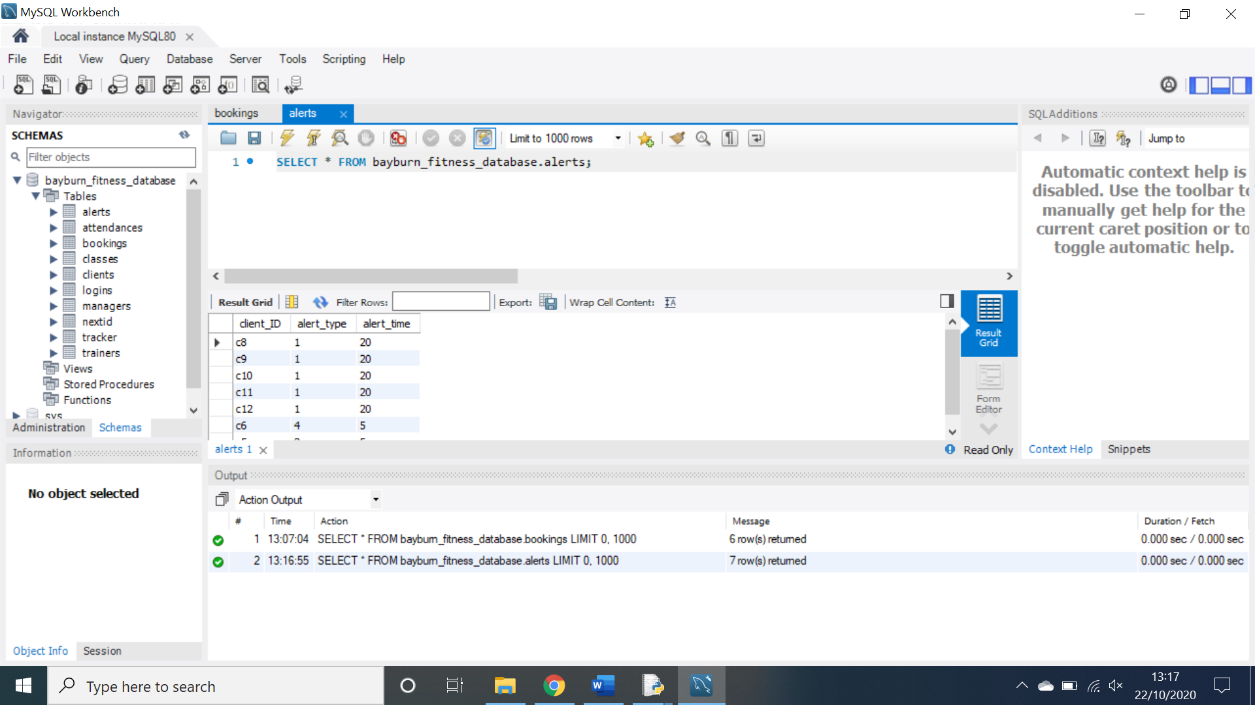

When a client updates their alert preferences, that information is then updated in the database in the above format.

**Fitness tracker:**

The client can navigate to this screen by clicking the top right-hand button. This screen allows the client to track their fitness progress by recording their weight, reps, sets and time taken for a specific exercise.

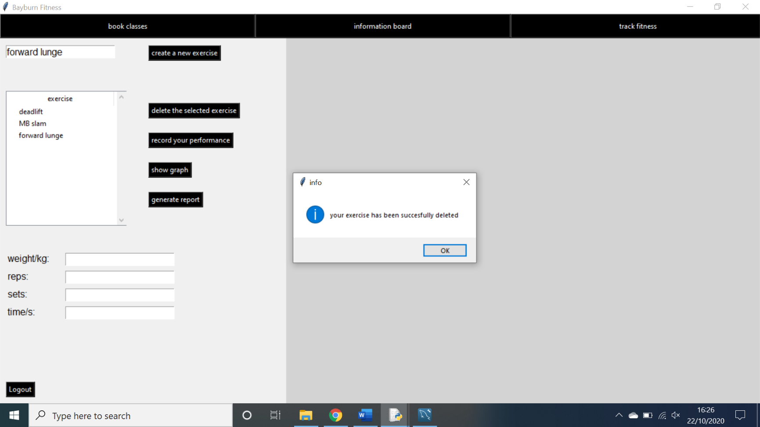To add an exercise the client simply needs to type the name of the exercise into the entry box and click the add exercise button, as shown above this will generate a confirmation message and the exercise will be added to the system. If the user tries to add an exercise that already exists the system will generate an error message.

To delete an exercise the client simply needs to select one and click the delete exercise button. If an exercise is not selected an error message will be generated.

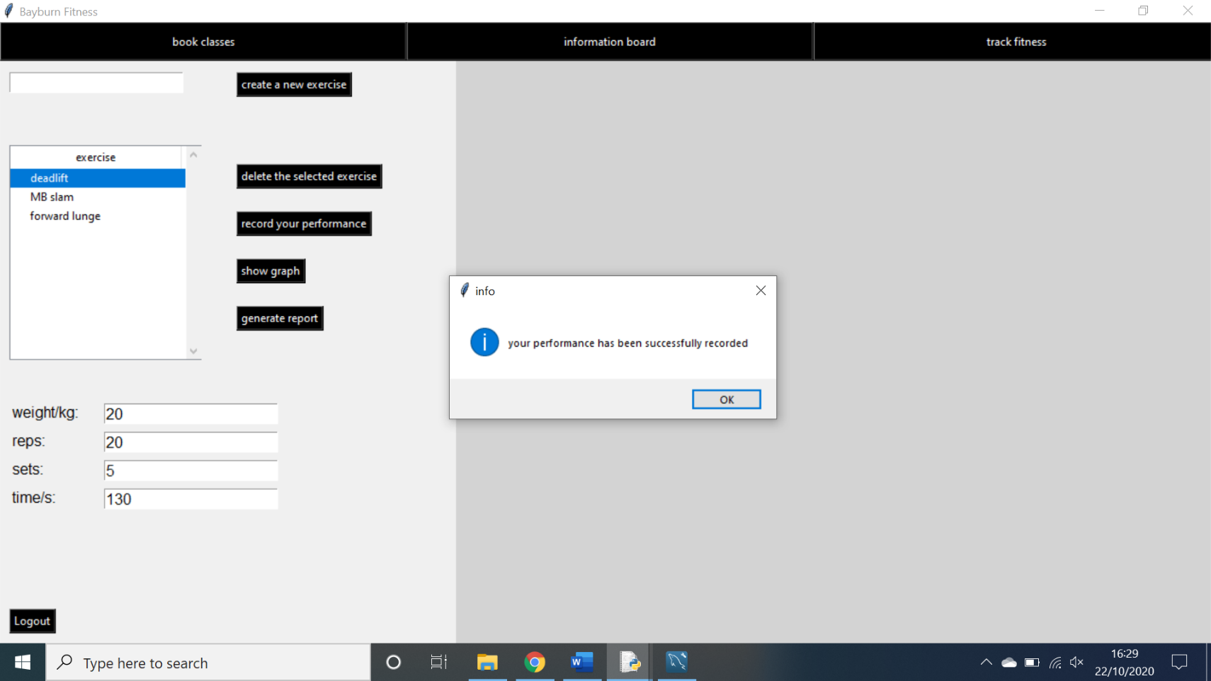

In order to add data to an exercise, the user must simply fill in the entry boxes at the bottom of the screen and click the record performance button. If the user has entered incorrect or incomplete data the system will generate an error message.

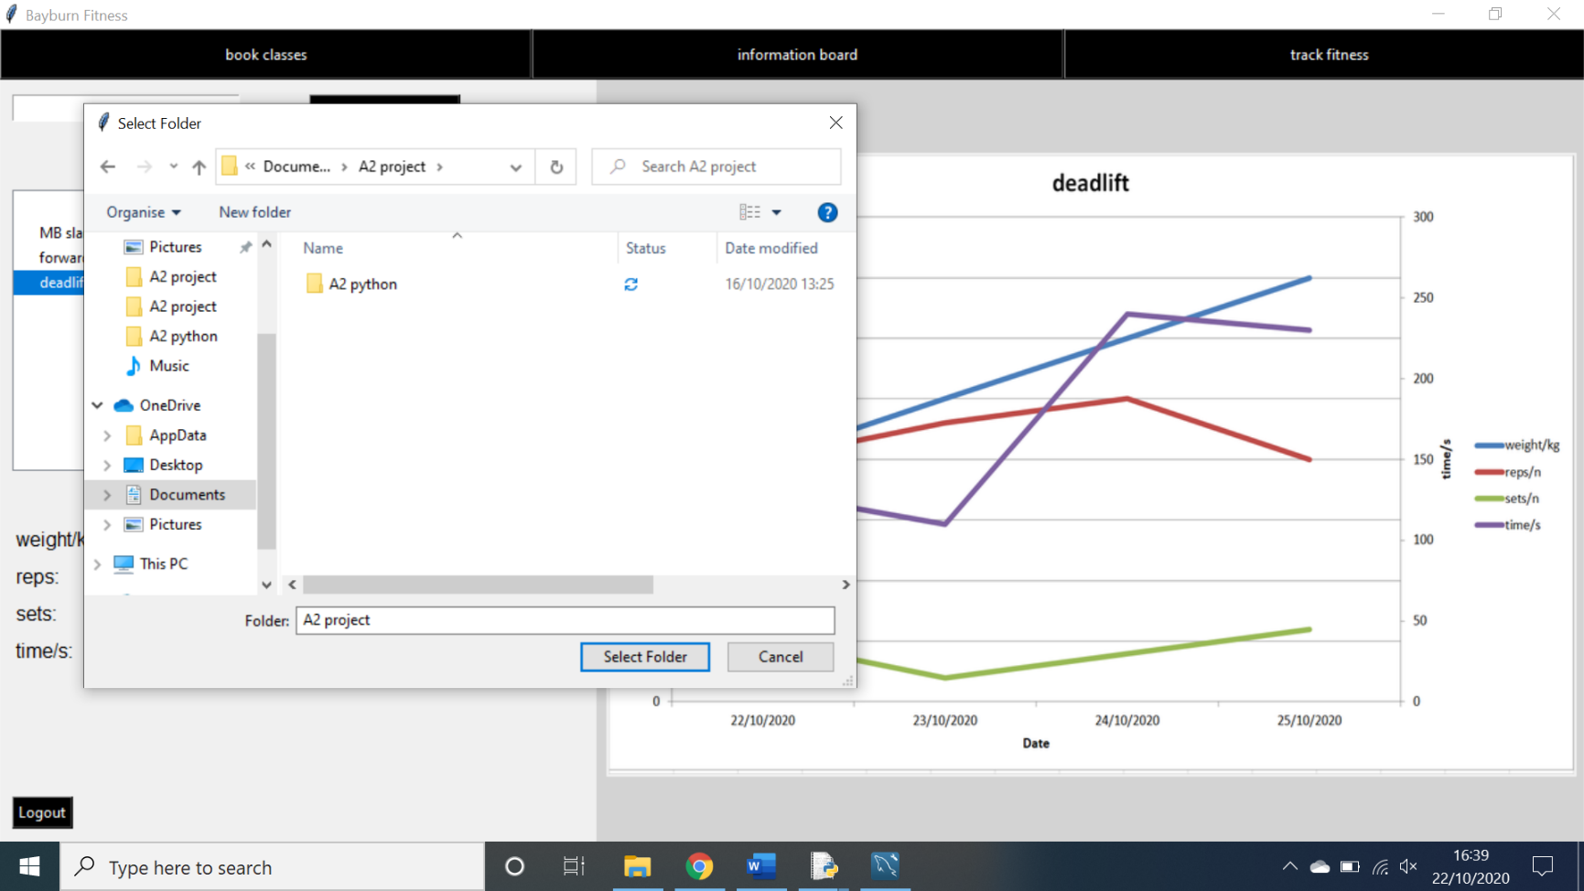In order to generate a graph of a specific exercise, simply select an exercise and click the show graph button. If there is no data to plot for an exercise, then an error message will be generated. Otherwise a graph will be plot for the recorded data against the date.

In order to generate a report, the client simply needs to select an exercise and click the generate report button. If there is no data to report the system will generate an error message. Otherwise the system will open a file interface window and prompt the user to save the report in a specific file.

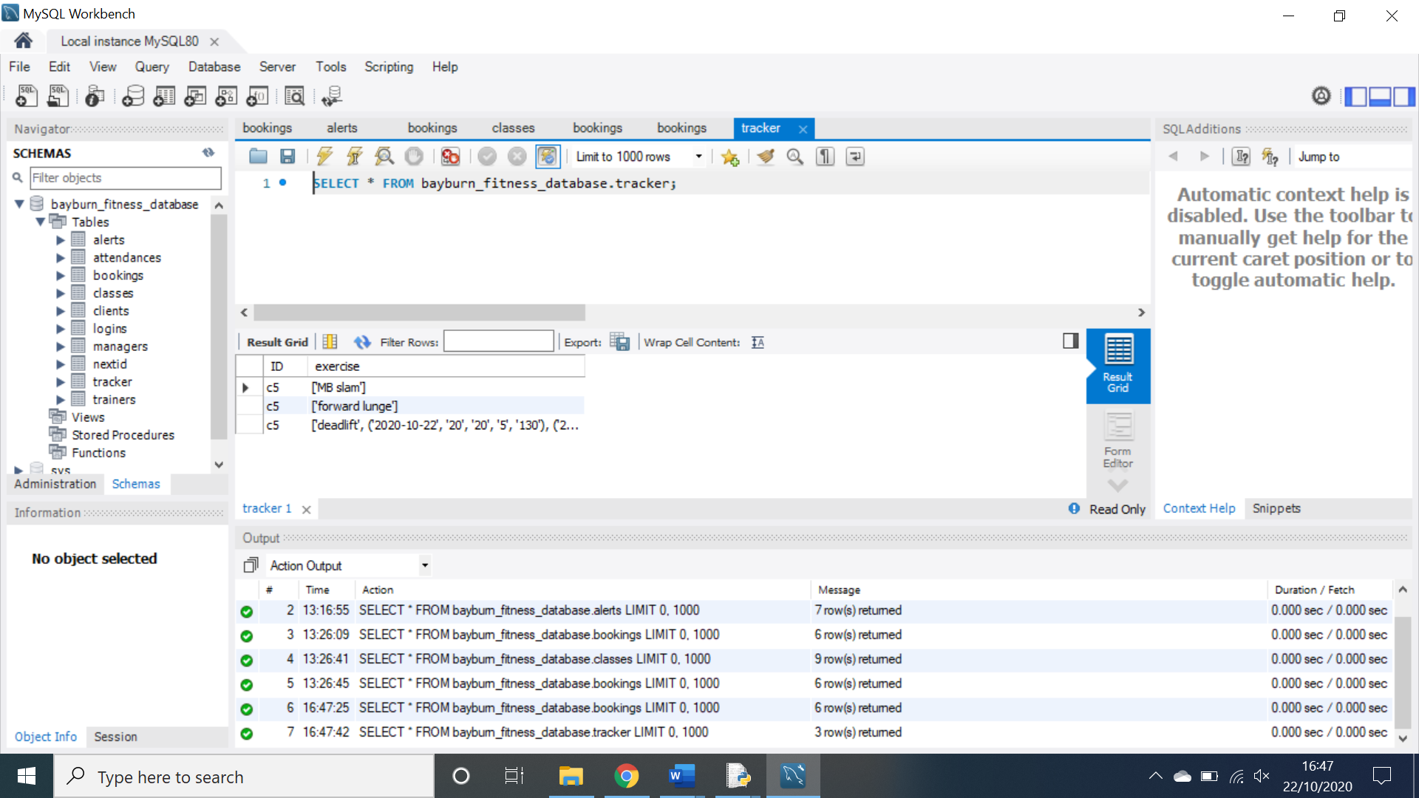the report will be saved where the user selected and given the name of the exercise. It will contain an overview of all data used to create the report along with the graph generated from it.

When an exercise is created, it is added to the database in the form of a two-dimensional list. At the beginning of the list is the name and the rest of the list is the separate data entries of the exercise, each one includes the date, weight, reps, sets and time. When an exercise is deleted, it is deleted from the database and the screen is updated.

**Create class page:**

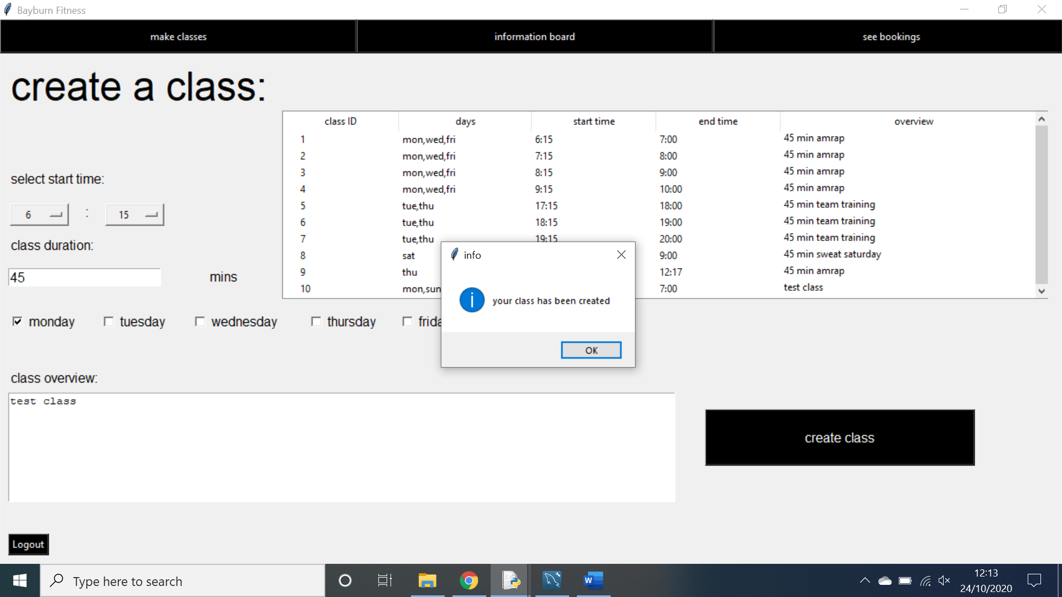This is the page that a trainer is first greeted with upon logging into the system. This page allows the trainer to create, view and delete their classes.

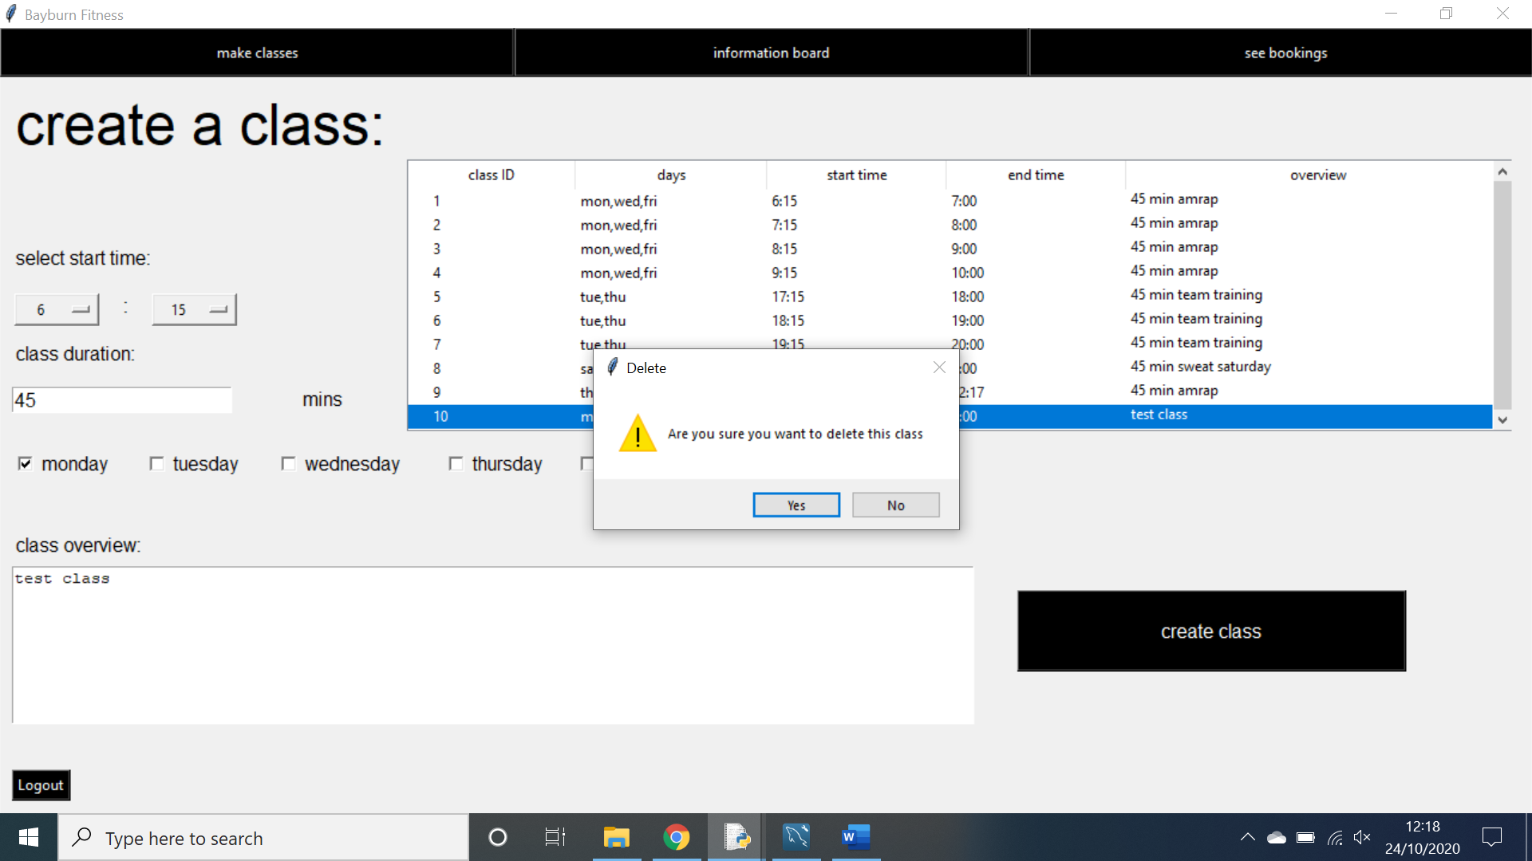In order for the trainer to create a class, they must fill in the start time, class duration, which days of the week the class will be held and a small description of the class. Once this is done the trainer can click create class and the class will be added to the system and the treeview will be updated. The class will not be created if the class duration is not a number and an error message will be generated. The treeview is populated with all the classes that the trainer has created.

When the trainer clicks on any class in the treeview, it will ask the trainer if they wish to delete the class, if they click yes, the class will be deleted from the system and the treeview will be updated.

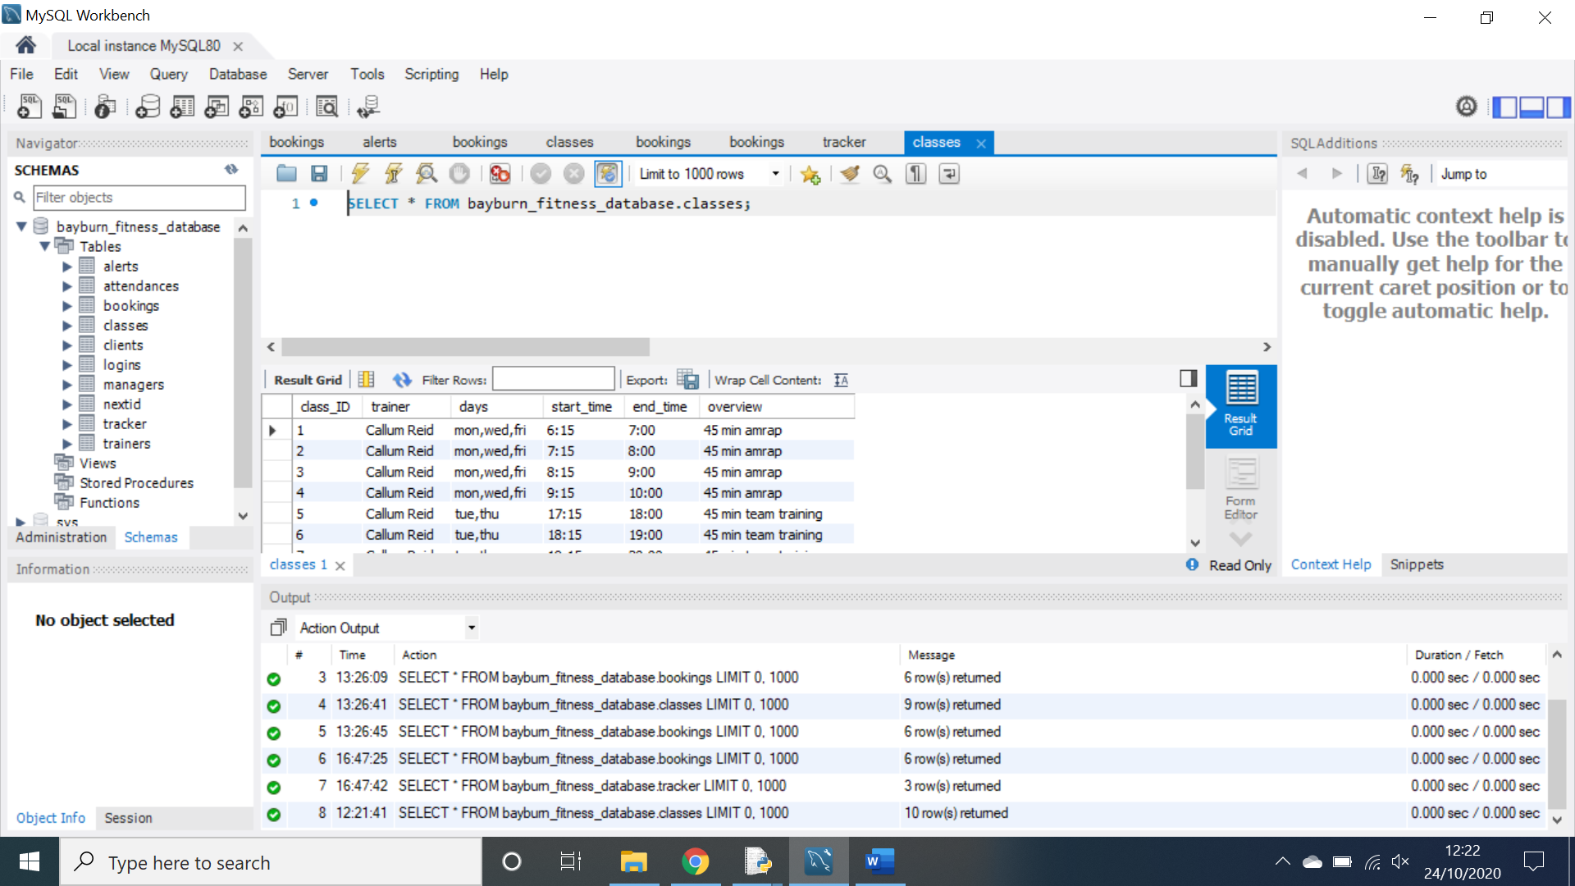

When a class is created, it is added to the database in the above format. When a class is deleted the class is removed from the database. When a class is deleted. All associated bookings for that class are also deleted to uphold referential integrity.

**view bookings page:**

this page can be navigated to by clicking the see bookings button on the top right-hand corner of the screen. On this screen, the trainer can see all of their classes for the next 30 days and see which clients have booked into them.

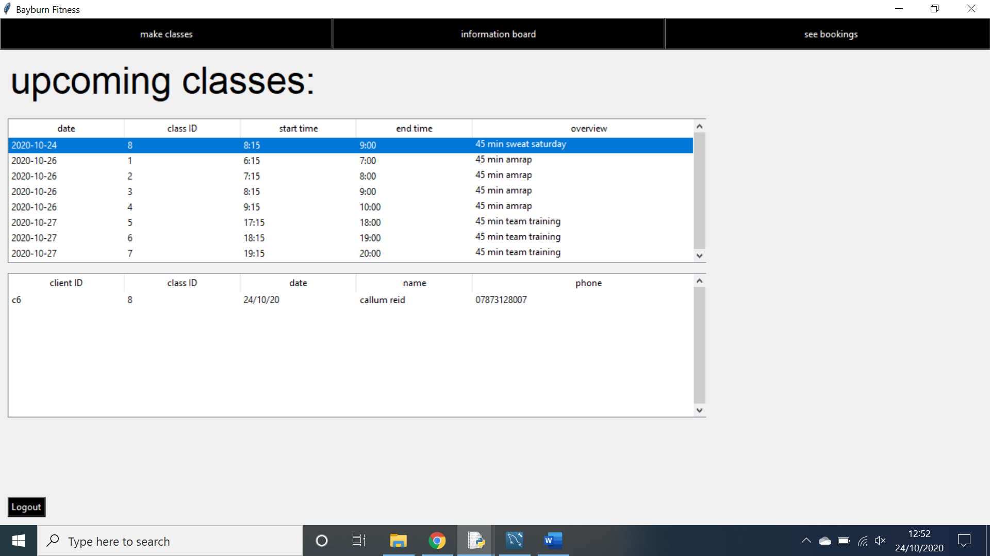

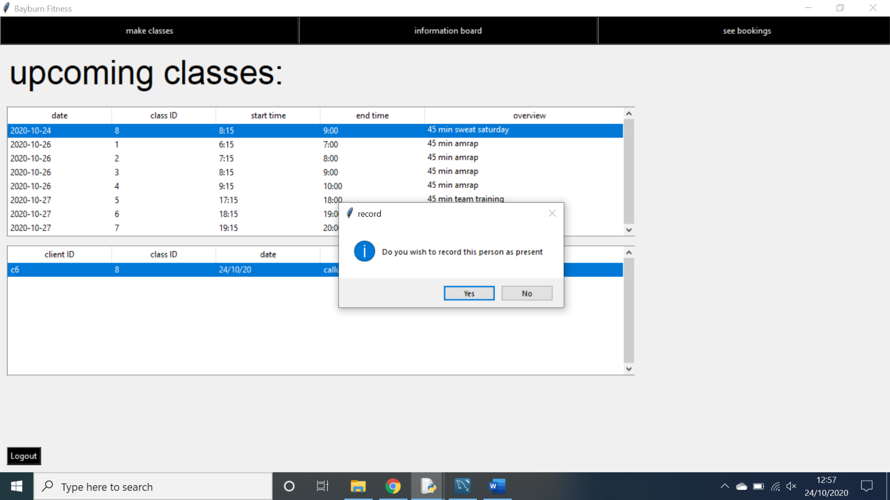The top treeview is populated with all of the trainer’s classes that are happening in the next 30 days. In order to view who is attending the classes, the trainer must simply click on one of them and the clients who have booked into these classes will be populated in the bottom treeview.

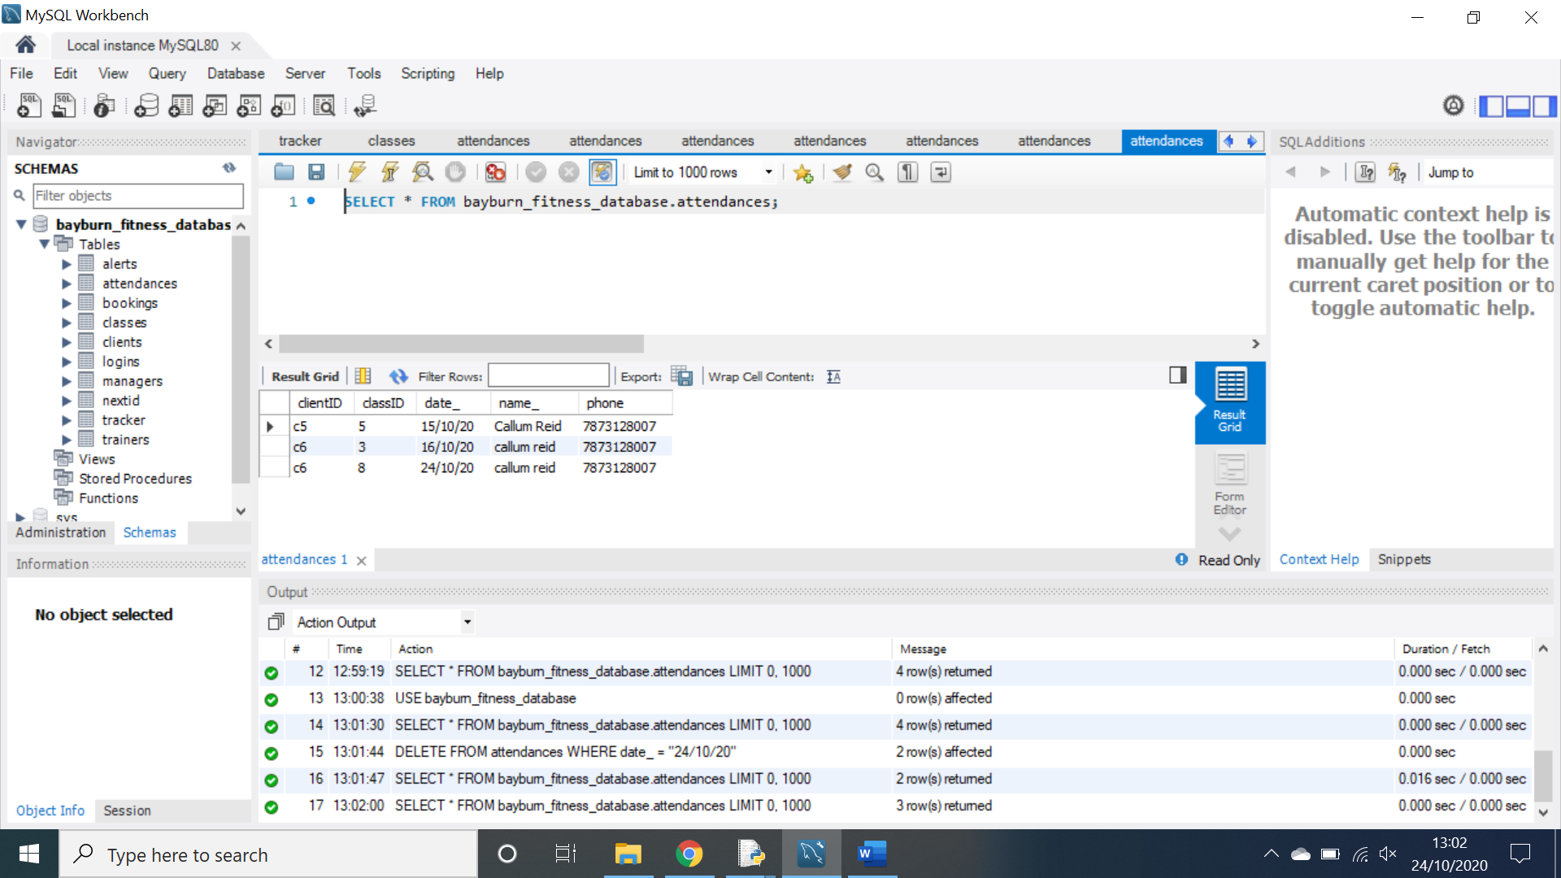In order to record someone as present, the trainer must click on their name on the bottom treeview. This will prompt the user to confirm that they wish to record them as present and if so it will record them as present for this class, this can however only be done on the day of the class. If you try to record someone as present for a class that is not today, an error message will be generated.

When an attendance is recorded, it is added to the database in the above format. Duplicate attendances are also deleted at this point.

**Add person page:**

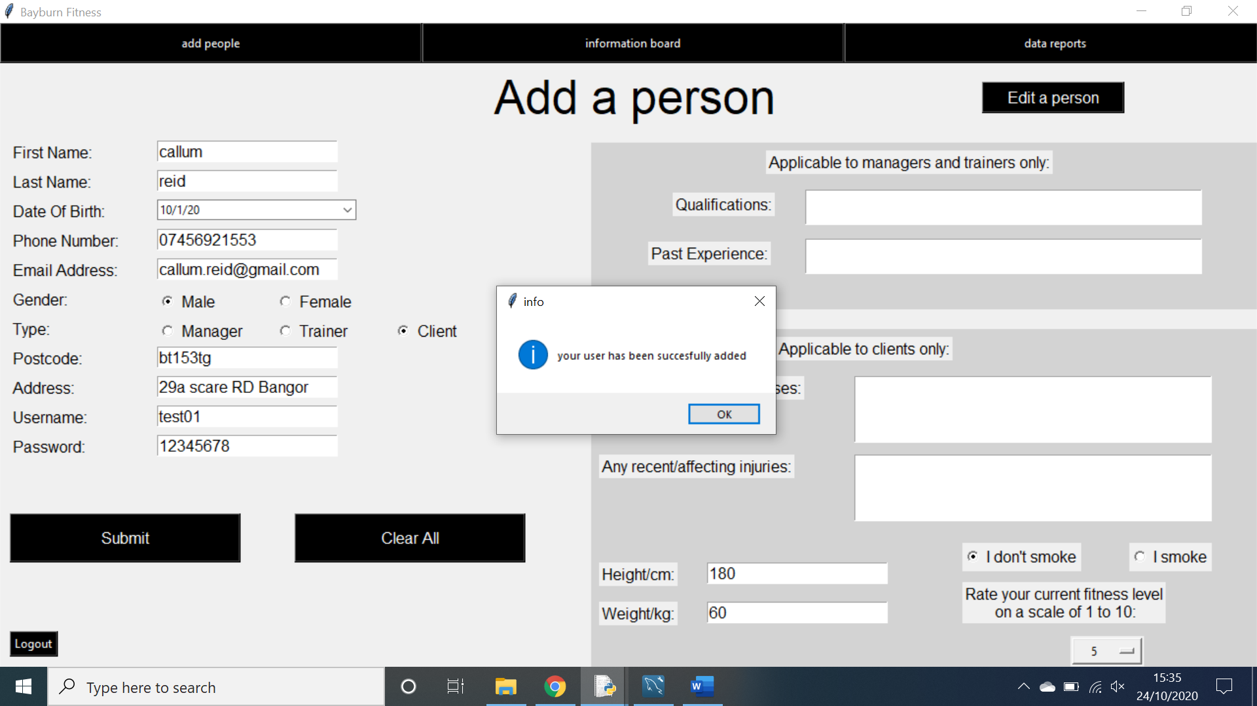This page is the first page you are greeted with when logging in as a manager. On this page you are able to create an account for any stakeholder in order to let them use the system.

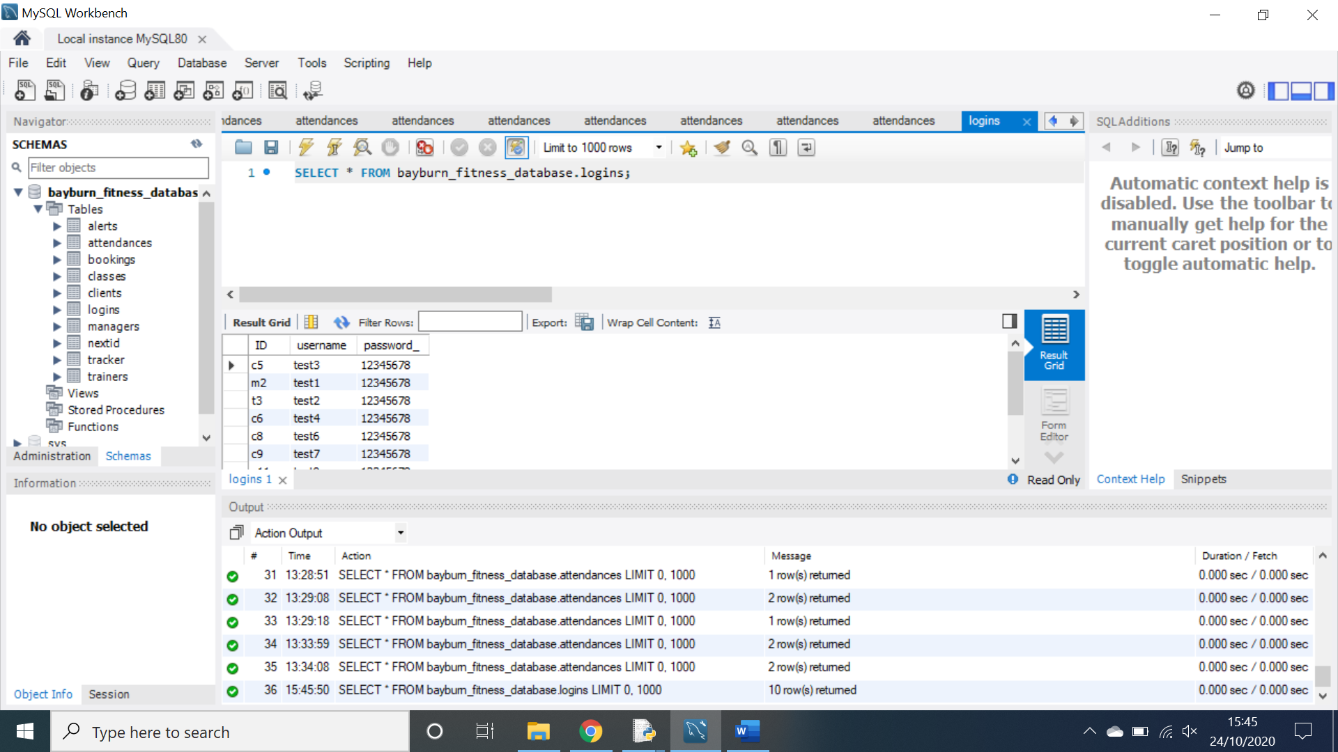In order to add a client, you must fill out all the relevant information in as shown above and click submit. If the name, phone number or email address is invalid, it will produce an error message. If the username has already been taken or the password is below 8 characters long, then an error message will be generated. If left empty the illnesses and injuries boxes will gain the value of ‘none’. Once submitted, a new client will be added to the database. If the user wishes to add a manager or trainer, they must simply fill out the data applicable to managers and trainers instead of clients.

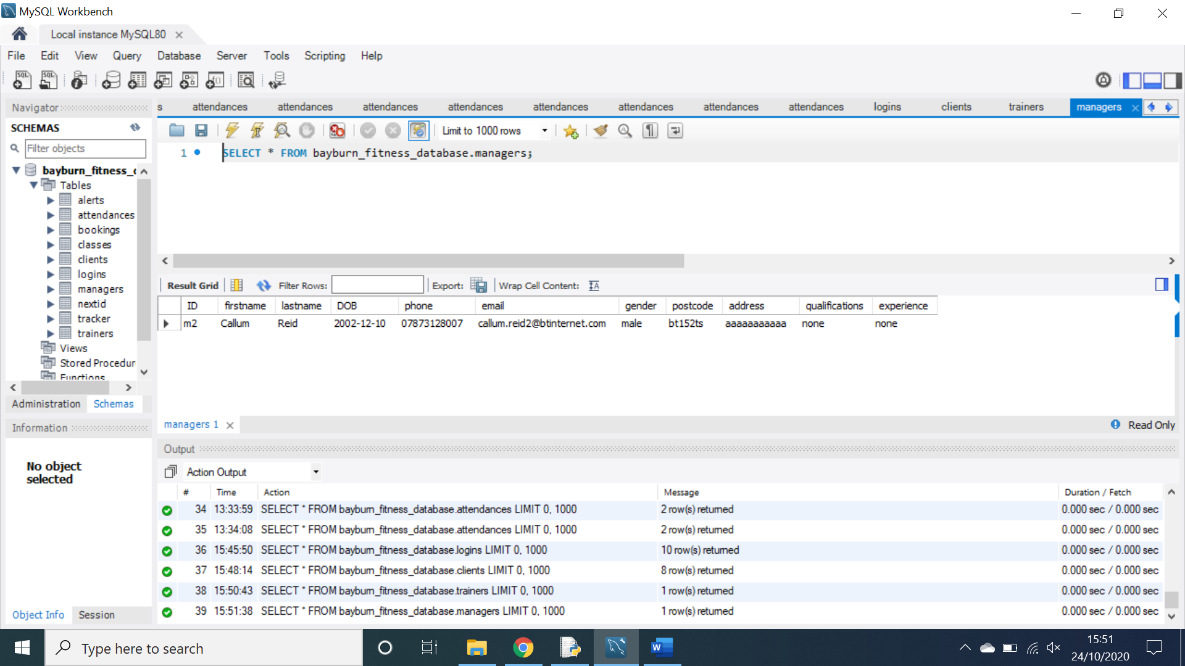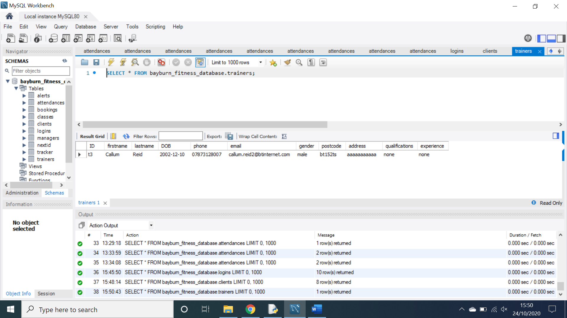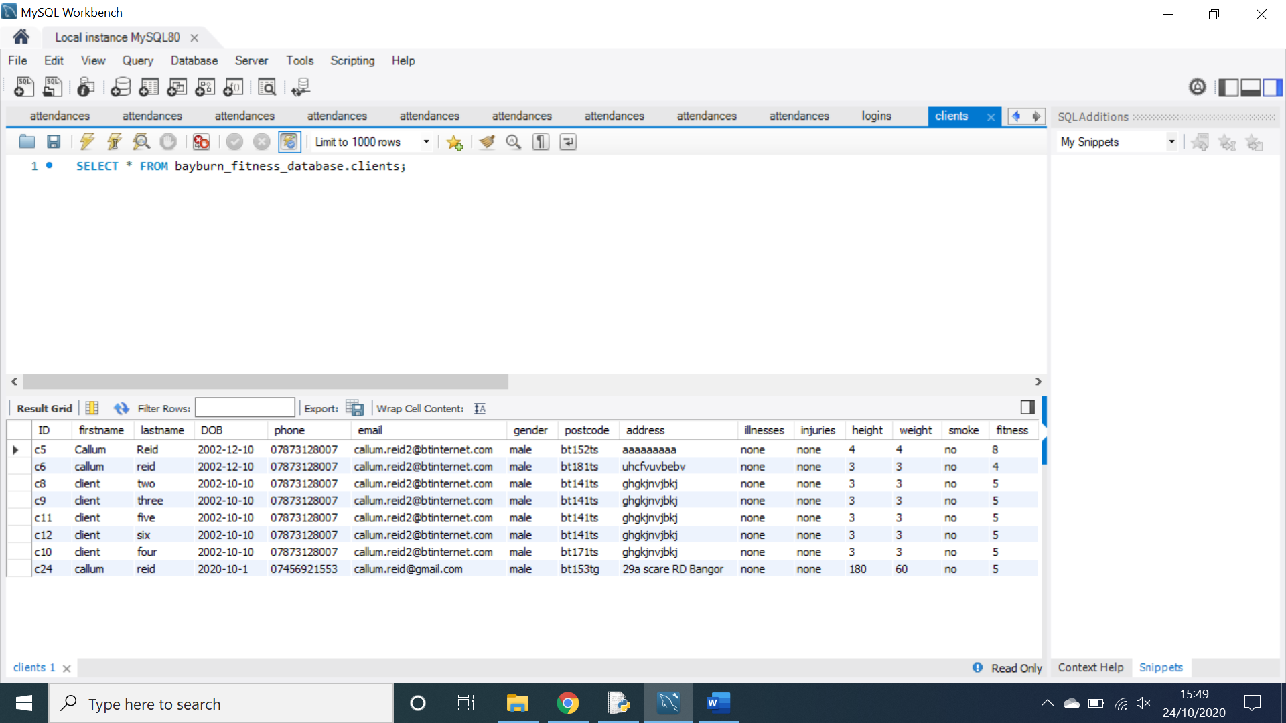Once a new person is added, their ID is generated and login details are added to the database as shown above.

When a user is added their personal info is added to their respective table in the database as shown above with the clients, trainers and managers table.

When a manager clicks on the edit person button, they are redirected to this page. Here they can search for a person to edit, view or delete.

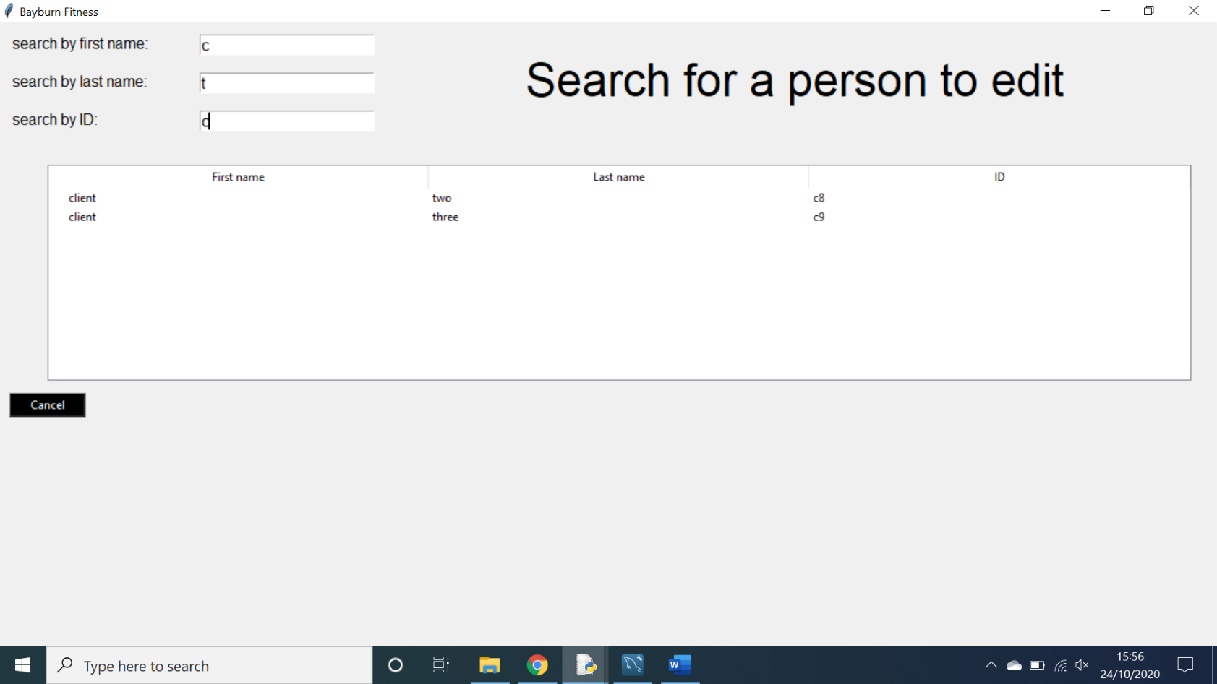

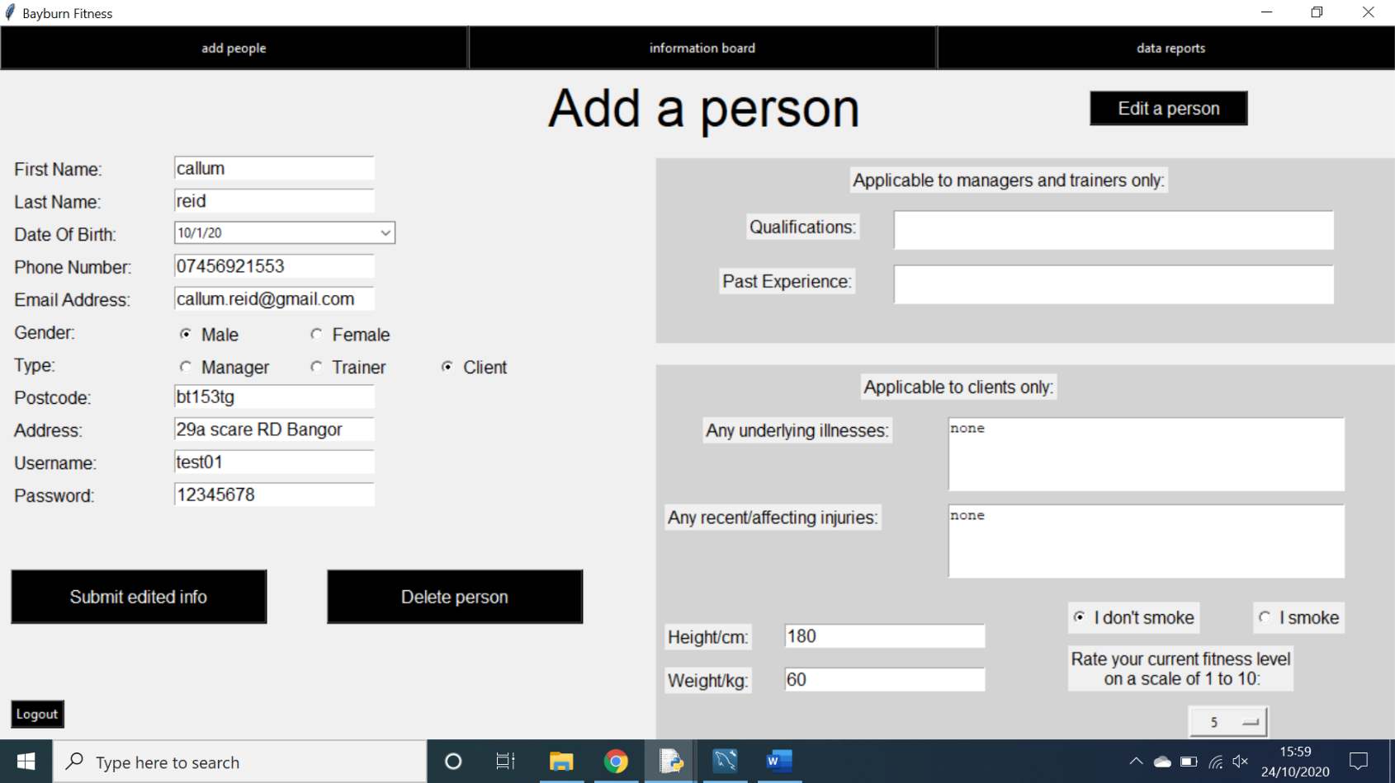By using the entry boxes at the top of the screen, the user can narrow down the search window in order to find whichever user they are looking for.

When a user is selected on the treeview, their info is populated onto the original screen and can be edited. If the user wishes to submit the new info, they can simply click the submit edited info button, or they can delete the user from the database entirely by clicking the delete person button. All data will then be updated in the database.

**Prototype evaluation:**

After completing this prototype, I can confidently say that I am pleased with how it turned out. I have been able to effectively implement several pieces of functionality that allow my system to work well and I have been able to create, retrieve, update and delete from a database effectively. I think that this prototype has shown that I have the skill necessary to complete the prototype. There are however some areas for improvement.

**Strengths of the prototype:**

* All interfaces are intuitive and easy to use as well as being easy to navigate around using the simple buttons at the top of the screen.
* All users can log in easily and immediately be redirected to the appropriate pages for their stakeholder.
* Managers can easily add any new people to the system as well as edit and delete people that have already been added.
* Trainers can easily create classes for clients to book into as well as delete classes that have previously been created.
* Trainers can view all of their classes for the next 3o days as well as check which clients have booked into these classes.
* Trainers can record the attendance of clients for classes that they have been to on the current day.
* Clients can book themselves into classes that have been created by trainers as well as delete bookings that were made previously.
* Clients can track their fitness using the fitness tracker by recording their performance and generating a line graph to show their progress.
* Clients can generate a report of their fitness progress, including all previous performances and a line graph of all performances.
* All data entered into the system is validated to ensure that if a user inputs invalid data, they are notified via an error message.
* When a trainer is deleted from the database, all of their classes and associated bookings are also deleted to uphold referential integrity.
* When deleting users from the database, referential integrity is upheld throughout the multiple tables of the database.
* The same aesthetic scheme is maintained throughout the system.

**Weaknesses of the prototype:**

* There is currently no way of verifying a postcode using python.
* When generating a graph for the client’s fitness tracker, the system slows down due to the long process of generating an excel file, creating a chart, extracting the chart from the file and finally adding it to the screen.
* There is currently no way of transferring money via python and so there is no way of creating an automatic payment system.
* I was have not implemented encryption into the prototype yet, however this should be rectified once the project is completed.
* On some of the GUIs there are areas of unused space that can look aesthetically unpleasing.
* There is no Bayburn fitness logo on any of the screens.

**Suggestions for improvement:**

* The system must be completed, including all features that were left out of the prototype. Additional functionality may also be added to ensure the system is as useful as possible.
* Some of the screens may be restructured to create less free space and make room for more Bayburn fitness logos.
* I will optimise the system to ensure it runs as fast as possible, this may include creating functions for pieces of code that repeat often, finding more efficient ways of processing data and refining the user interface.